**Part 1: Meal Price Calculation with Tip and Tax**

//Pseudocode://

1. Ask the user for the meal cost.

2. Calculate the tip as 18% of the meal cost.

3. Calculate the sales tax as 7% of the meal cost.

4. Calculate the total amount by adding the meal cost, tip, and tax.

5. Display the tip, tax, and total amount to the user.

**Python Code:**

# Part 1: Calculate total amount for a meal

meal_cost = float(input("Enter the meal cost: $"))

# Calculate tip and tax

tip = meal_cost * 0.18

tax = meal_cost * 0.07

# Calculate total amount

total_amount = meal_cost + tip + tax

# Display results

print(f"Tip: ${tip:.2f}")

print(f"Tax: ${tax:.2f}")

print(f"Total amount: ${total_amount:.2f}")

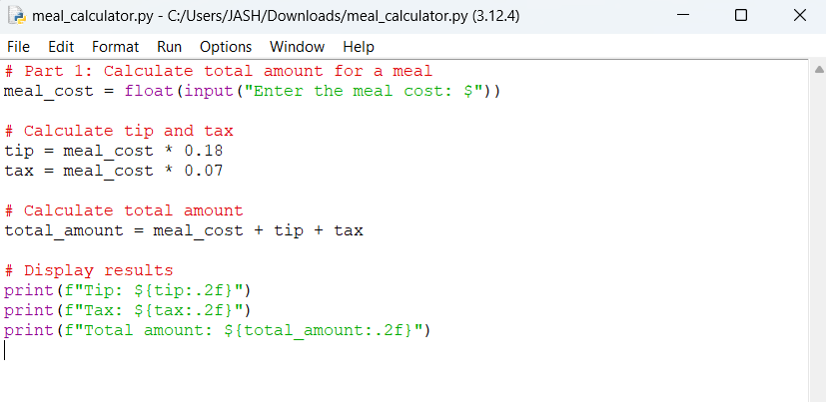

**Execute Code:**

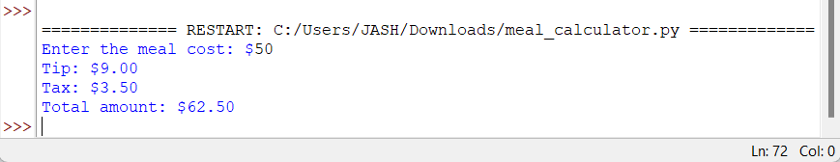

**Part 2: 24-Hour Clock Alarm**

//Pseudocode://

1. Ask the user for the current time (in hours, 0 to 23).

2. Ask the user for the number of hours to wait for the alarm.

3. Add the current time to the number of hours to wait.

4. Use the modulus operator (`%`) with 24 to calculate the new time on the 24-hour clock.

5. Display the final time when the alarm will go off.

**Python Code:**

# Part 2: Calculate when the alarm will go off

current_time = int(input("Enter the current time (in hours, 0-23): "))

wait_hours = int(input("Enter the number of hours to wait for the alarm: "))

# Calculate the alarm time

alarm_time = (current_time + wait_hours) % 24

# Display the result

print(f"Alarm will go off at: {alarm_time}:00")

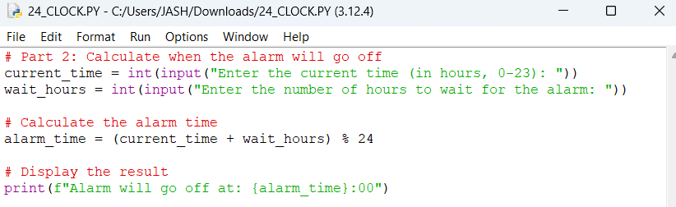

**Execute Code:**



